# Chapter 1: CRUD

## Create MVC Project

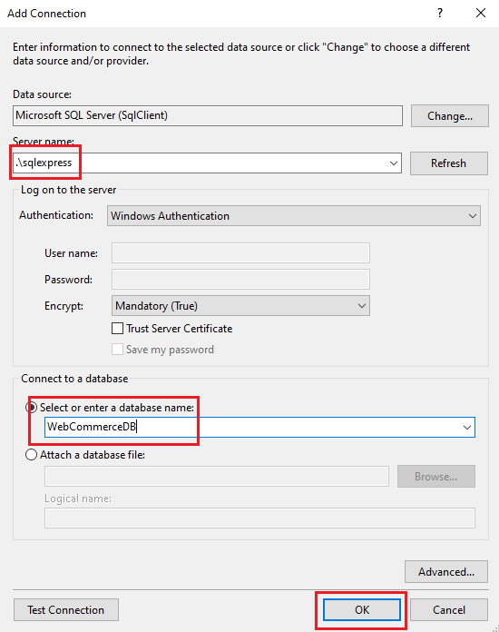



## Add Package

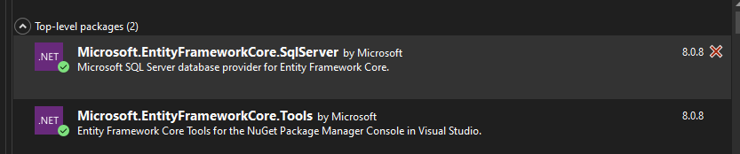

## Create and Register the ApplicationDBContext

Step1: Create this:

-->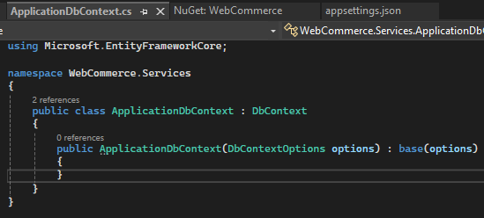

Step2:

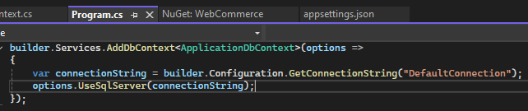

## Create the Product Model

Step1:

Create this Model name “Product”

-->